

Model-Driven Conceptual Design

System Design and Management School

西村研究室

Shared_Bicycle_with_Energy

Author:

Revision:

|  |  |
| --- | --- |
|  |  |
|  | Date: October 24, 2022 |

# Model Introduction

**Model** **Specification>Documentation**

Author: Hiroyasu Ishikawa

Created:4/17/17 4:29 PM.

Title: Shared bicycle also share energy

Comment:. This is a model for a higher quality bicycle sharing service.

# All Project Diagrams

## Ideas and Assumption Diagram

**Diagram Specification>Documentation**

**In:** Concept Model.Data.Ideas and Assumption Diagram

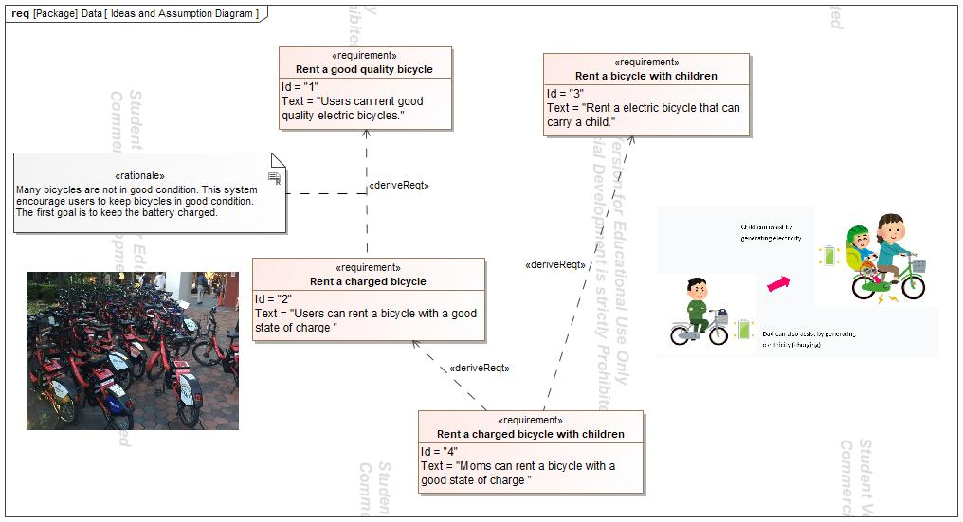

1. Diagram Ideas and Assumption Diagram

## Get on Mom or Dad's Bicycle

**Diagram Specification>Documentation**

**In:** Concept Model.Get on Mom or Dad's Bicycle.Get on Mom or Dad's Bicycle.Get on Mom or Dad's Bicycle

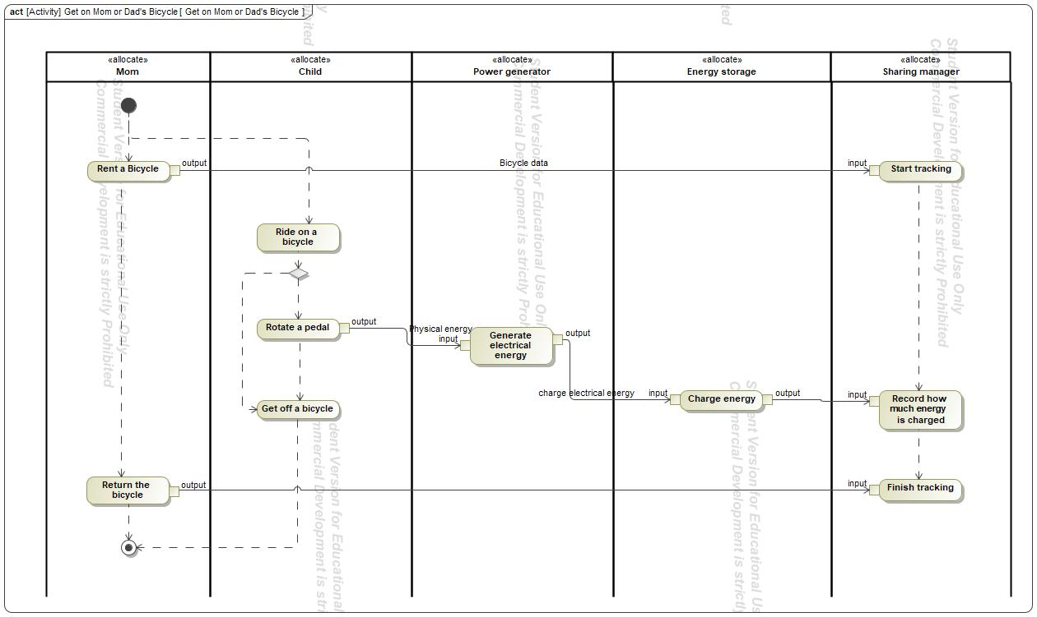

1. Diagram Get on Mom or Dad's Bicycle

## Mapping Concept to PoC

**Diagram Specification>Documentation**

**In:** Proof of Concepts.Procurement PoC1.Mapping Concept to PoC

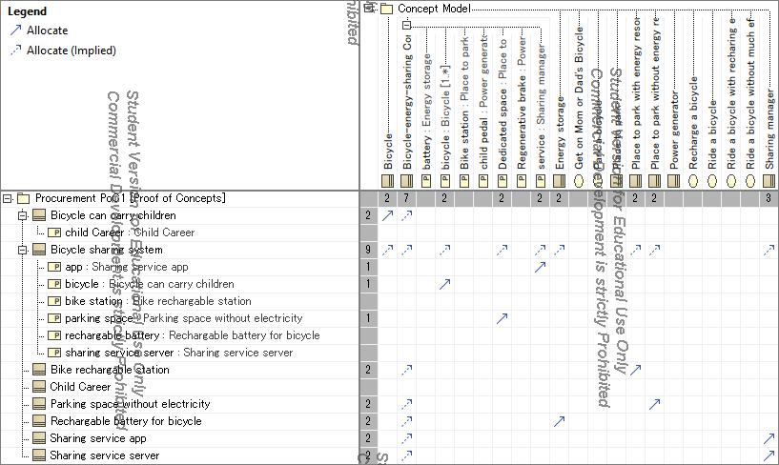

1. Diagram Mapping Concept to PoC

## Park a bicycle

**Diagram Specification>Documentation**

**In:** Concept Model.Park a bicycle.Park a bicycle.Park a bicycle

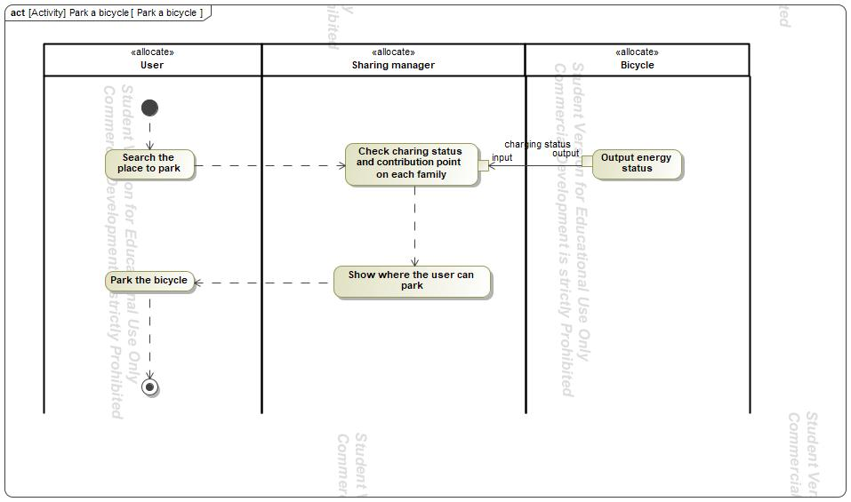

1. Diagram Park a bicycle

## Bicycle-energy-sharing Concept

**Diagram Specification>Documentation**

**In:** Concept Model.Bicycle-energy-sharing Concept.Bicycle-energy-sharing Concept

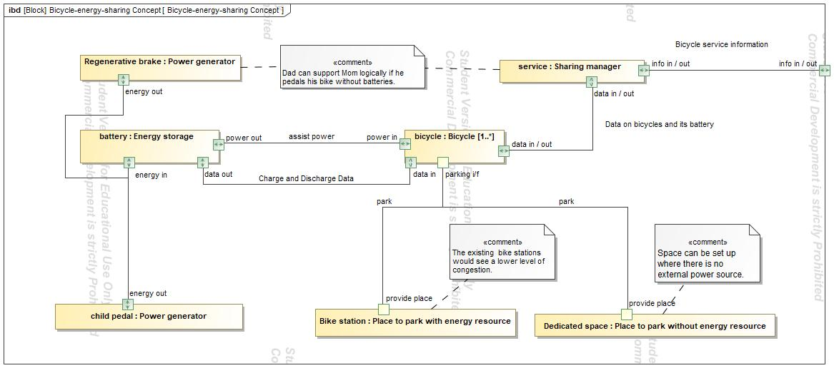

1. Diagram Bicycle-energy-sharing Concept

## Product Use Case Diagram

**Diagram Specification>Documentation**

**In:** Concept Model.Product Use Case Diagram

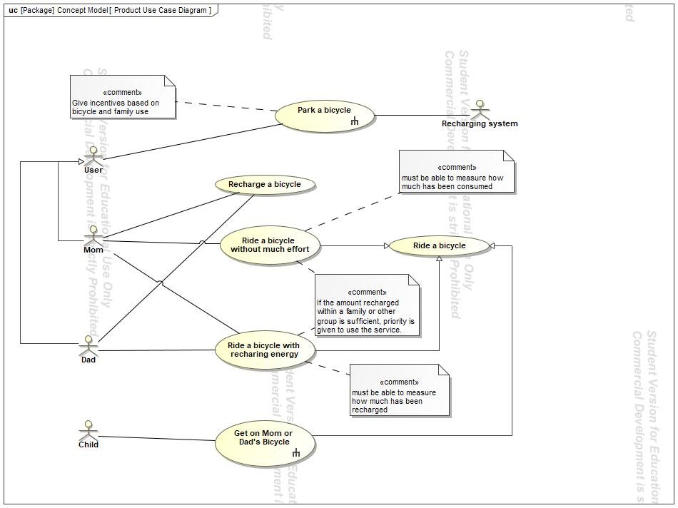

1. Diagram Product Use Case Diagram

## Concept Model

**Diagram Specification>Documentation**

**In:** Concept Model.Concept Model

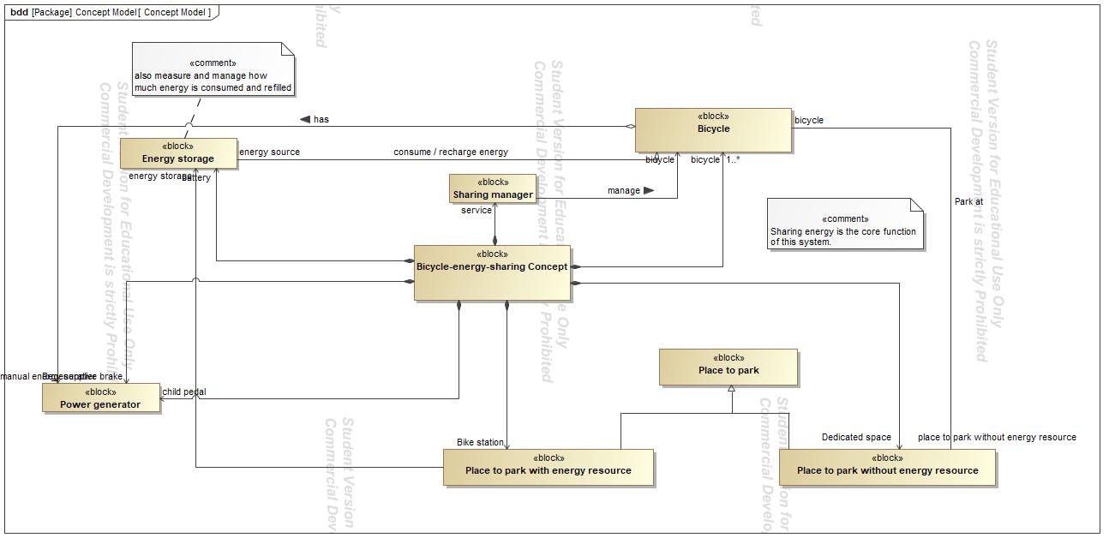

1. Diagram Concept Model

## PoC Service Activities

**Diagram Specification>Documentation**

**In:** Proof of Concepts.Services.PoC Service Activities.PoC Service Activities

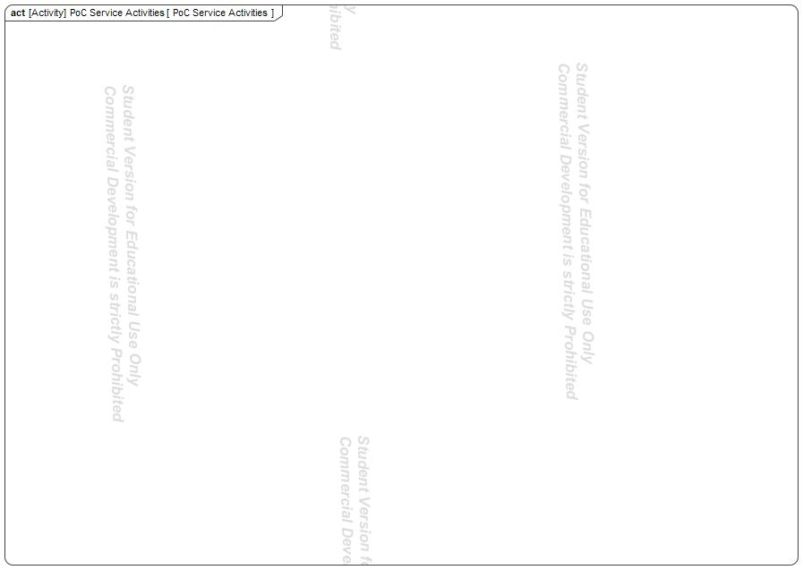

1. Diagram PoC Service Activities

## PoC Blocks

**Diagram Specification>Documentation**

**In:** Proof of Concepts.Procurement PoC1.PoC Blocks

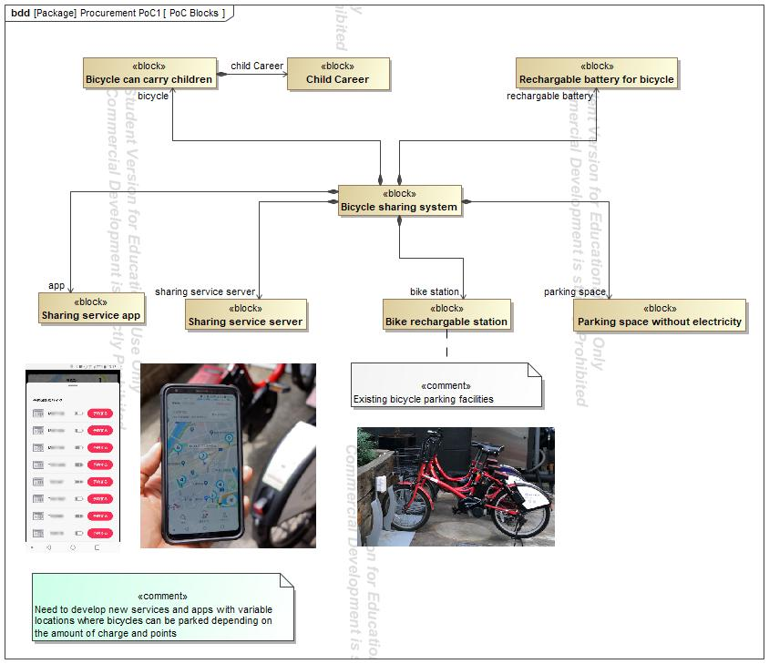

1. Diagram PoC Blocks

# Concept Use-Cases

|  |
| --- |
| **UseCase** |
| Get on Mom or Dad's Bicycle |
| Park a bicycle |
| Recharge a bicycle |
| Ride a bicycle |
| Ride a bicycle with recharing energy |
| Ride a bicycle without much effort |

## Actor Summary

|  |  |
| --- | --- |
| **Primary Actor** | **Use Cases** |
| Child | * Get on Mom or Dad's Bicycle |
| Dad | * Recharge a bicycle      * Ride a bicycle with recharing energy |
| Mom | * Recharge a bicycle      * Ride a bicycle with recharing energy      * Ride a bicycle without much effort |
| Recharging system | * Park a bicycle |
| User | * Park a bicycle |

## Use Case: Product Use Case Diagram Diagram



## Get on Mom or Dad's Bicycle Use Case

|  |  |  |  |
| --- | --- | --- | --- |
| **Use Case Name** | Get on Mom or Dad's Bicycle | ID |  |
| **Complexity** | Average Complexity | | |
| **Description** | The child can supply energy by pedaling at the same time as riding the parent's bicycle. | | |
| **Actors** | * Child | | |
| **Goal** |  | | |
| **Assumption** | No assumption for this use case. | | |
| **Non Functional Requirements** | No non-functional requirement for this use case. | | |

|  |  |
| --- | --- |
| **Relations** | |
| **Association** | * Child Actor |
| **Generalization** | * Ride a bicycle UseCase |

## Park a bicycle Use Case

|  |  |  |  |
| --- | --- | --- | --- |
| **Use Case Name** | Park a bicycle | ID |  |
| **Complexity** | Average Complexity | | |
| **Description** | The user can park bicycles where there are no facilities to supply energy. | | |
| **Actors** | * Recharging system * User | | |
| **Goal** |  | | |
| **Assumption** | No assumption for this use case. | | |
| **Non Functional Requirements** | No non-functional requirement for this use case. | | |

|  |  |
| --- | --- |
| **Relations** | |
| **Association** | * Recharging system Actor * User Actor |
| **Generalization** |  |

## Recharge a bicycle Use Case

|  |  |  |  |
| --- | --- | --- | --- |
| **Use Case Name** | Recharge a bicycle | ID |  |
| **Complexity** | Average Complexity | | |
| **Description** | The user charges energy without moving the bicycle. | | |
| **Actors** | * Dad * Mom | | |
| **Goal** |  | | |
| **Assumption** | No assumption for this use case. | | |
| **Non Functional Requirements** | No non-functional requirement for this use case. | | |

|  |  |
| --- | --- |
| **Relations** | |
| **Association** | * Dad Actor * Mom Actor |
| **Generalization** |  |

## Ride a bicycle Use Case

|  |  |  |  |
| --- | --- | --- | --- |
| **Use Case Name** | Ride a bicycle | ID |  |
| **Complexity** | Average Complexity | | |
| **Description** |  | | |
| **Actors** | See parent class for actor associations | | |
| **Goal** |  | | |
| **Assumption** | No assumption for this use case. | | |
| **Non Functional Requirements** | No non-functional requirement for this use case. | | |

|  |  |
| --- | --- |
| **Relations** | |
| **Association** | No direct association to this use case. Check the parent use case (see Generalization below.) |
| **Generalization** |  |

## Ride a bicycle with recharing energy Use Case

|  |  |  |  |
| --- | --- | --- | --- |
| **Use Case Name** | Ride a bicycle with recharing energy | ID |  |
| **Complexity** | Average Complexity | | |
| **Description** | The user can ride a bike with charging energy, can also ride without charging. | | |
| **Actors** | * Dad * Mom | | |
| **Goal** |  | | |
| **Assumption** | No assumption for this use case. | | |
| **Non Functional Requirements** | No non-functional requirement for this use case. | | |

|  |  |
| --- | --- |
| **Relations** | |
| **Association** | * Dad Actor * Mom Actor |
| **Generalization** | * Ride a bicycle UseCase |

## Ride a bicycle without much effort Use Case

|  |  |  |  |
| --- | --- | --- | --- |
| **Use Case Name** | Ride a bicycle without much effort | ID |  |
| **Complexity** | Average Complexity | | |
| **Description** | Ride a bicycle without much effort using the charged energy. | | |
| **Actors** | * Mom | | |
| **Goal** |  | | |
| **Assumption** | No assumption for this use case. | | |
| **Non Functional Requirements** | No non-functional requirement for this use case. | | |

|  |  |
| --- | --- |
| **Relations** | |
| **Association** | * Mom Actor |
| **Generalization** | * Ride a bicycle UseCase |